**Developer Questions**

1. What MuleSoft API-led connectivity layer is intended to expose part of a backend database without business logic?

* Experience
* Data
* System
* Process
* Security

2. What MuleSoft product enables publishing, sharing, and searching of APIs?

* API Designer
* Runtime Manager
* Anypoint Exchange
* API Notebook

3. Refer to the exhibit. What is the correct URL to submit a GET request to /patients?

[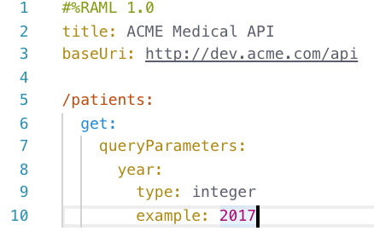](https://1.bp.blogspot.com/-RvXgstD9r9c/XqWSc5RrR9I/AAAAAAAACAs/MiSjeKrn8aE6i9Oi4gXyA76bYFQ_5mjLwCLcBGAsYHQ/s1600/RAML.png)

* http://dev.acme.com/patients?year=2016
* http://dev.acme.com/api/patients
* http://dev.acme.com/patients
* http://dev.acme.com/api/patients?year=2016

4. A RAML example fragment named BankAccountsExample.raml is placed in the examples folder in an API specification project. What is the correct syntax to reference the fragment?

* examples: !include BankAccountsExample.raml
* examples: #import BankAccountsExample.raml
* examples: !include examples/BankAccountsExample.raml
* examples: #import examples/BankAccountsExample.raml

5. What is the purpose of the api:router element in APIkit?

* Creates native connectors using a 3rd party Java library
* Serves as an API implementation
* Validates requests against RAML API specifications and routes them to API implementations
* Validates responses returned from API requests and routes them back to the caller

6. A Database connector is configured to select rows from a MySQL database. What is the format of the array of results returned from the database query?

* Java
* JSON
* XML
* CSV

7. How does APIkit determine the number of flows to generate from a RAML specification?

* Creates a separate flow for each resource
* Creates a separate flow for each resource that contains child resources
* Creates a separate flow for each HTTP method
* Creates a separate flow for each response status code

8. What is the purpose of API autodiscovery?

* Enables API Manager to discover the published API on Anypoint Exchange
* Allows the Mule application to be automatically discovered on Anypoint Exchange
* Enables an API to be directly managed in API Manager
* Allows a deployed Mule application to connect with API Manager to download policies and act as its own API proxy

9. API Manager has been configured to enforce an SLA policy and the RAML spec has been updated with the required client_id and client_secret header requirements. The new RAML spec has been published to Anypoint Exchange. What is the next step to gain access to the API?

* POST a JSON object to the /api/register endpoint of the API proxy
* Request access to the API in Anypoint Exchange
* Email the organization administrators to request access to the API
* Add a client application to the Anypoint Platform organization

10. What happens to the attributes of a Mule event in a flow after an outbound HTTP Request is made?

* New attributes may be added from the HTTP response headers, but no headers are ever removed
* Previous attributes are passed unchanged
* Attributes do not change
* Attributes are replaced with new attributes from the HTTP Request response (which might be null)

11. A flow contains an HTTP Listener as the event source. What is the DataWeave expression to log the Content-Type header using a Logger component?

* #["Content-Type: " ++ attributes.headers.'content-type']
* #["Content-Type: " + headers.'content-type']
* #["Content-Type: " + attributes.headers.'content-type']
* #["Content-Type: " ++ headers.'content-type']

12. A Mule application has two flows named parentFlow and childFlow. The childFlow begins with an HTTP Listener. A variable is defined in parentFlow, then an HTTP Request is made to childFlow's HTTP Listener with some headers set. What is the scope of the variable and attributes in the parentFlow after childFlow returns a response?

* The variable is accessible. All the attributes passed to childFlow are removed or replaced.
* The variable is NOT accessible. All the attributes passed to childFlow are removed or replaced.
* The variable is NOT accessible. All the attributes passed to childFlow are preserved.
* The variable is accessible. All the attributes passed to childFlow are preserved.

13. In what file does the Mule project keep track of all of its dependencies?

* mule-artifact.json
* pom.xml
* mule-app.properties
* global.xml

14. What can ONLY be done with VM connectors, and NOT with Flow References, in a single Mule application?

* Preserve variables as the Mule event gets passed to another flow
* Allow a flow to pass events to another flow synchronously
* Preserve the original payload when the VM connector returns a response from a flow
* Allow a flow to pass events to another flow asynchronously

15. What reserved property can be defined and used in a Mule application to allow an HTTPS Listener to be accessed by external web clients after the Mule application is deployed to CloudHub?

* ${ssl.port}
* ${ssl.listener.port}
* ${https.listener.port}
* ${https.port}

16. What file type is required to configure a Web Service Consumer to consume a SOAP web service?

* RAML
* WSDL
* JSON
* OAS

17. What is the process to create a connector using REST Connect?

* Develop the API in flow designer and publish the API to Exchange
* Design the API in Anypoint Studio and upload the API to Runtime Manager
* Design the API in Design Center and publish the API to Exchange
* Develop the API in Anypoint Studio and export the connector as a jar file

18. An HTTP Request operation returns a JSON array of objects. In the Transform Message component, what is the process to convert the array of objects to an array of custom Java Account objects?

* Add the Account object metadata to the output and use the drag-and-drop feature to transform the incoming JSON data
* Change the output type to the Java Account object type
* Add the Account object metadata to the input and the Transform Message component will automatically convert the JSON objects to Account objects
* Change the input type to the Java Account object type

19. A Scatter-Gather processes three separate HTTP requests. Each request returns a Mule event with a JSON payload. What is the final output of the Scatter-Gather?

* An Object containing all three Mule event Objects
* An Array of the three JSON payload Objects
* An Array of the three Mule event Objects
* An Object containing all three JSON payload Objects

20. Refer to the exhibits. What happens to this flow when the Validation module's Is not null operator throws an error?

[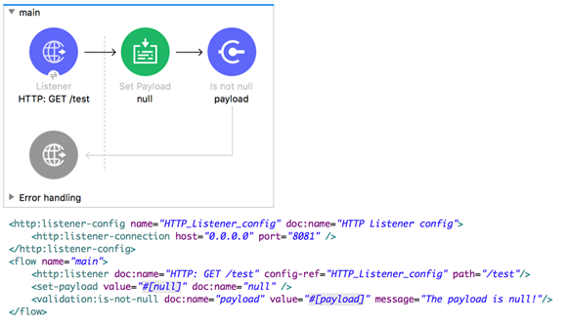](https://1.bp.blogspot.com/-ZzzgYWhUavk/XqWXGooyDMI/AAAAAAAACBI/12staodMb5krm9FAiahNuVWOoziBccjlgCLcBGAsYHQ/s1600/Validation.png)

* The flow silently stops processing its Mule event
* The flow stops processing its Mule event and returns an error message to the HTTP Listener operation
* The flow logs the error message in the console and continues processing its Mule event
* The flow continues processing its Mule event and appends the error message to the end of the payload

21. An event contains a payload that is an Array of Objects. How is the event routed in a Scatter-Gather?

* The ENTIRE event is sent to each route and processed SEQUENTIALLY
* The event is SPLIT and different SMALLER events are routed and processed in PARALLEL
* The event is SPLIT and different SMALLER events are routed and processed SEQUENTIALLY
* The ENTIRE event is sent to each route and processed in PARALLEL

22. Refer to the exhibits. The main flow has an On Error Continue scope. In the Configuration global element, default error handler is set to globalErrorHandler. A web client makes an HTTP GET request to the flow's HTTP Listener. The Is number validator then throws an error with message "Validate - Payload is an Integer". What response message is returned to the web client?

[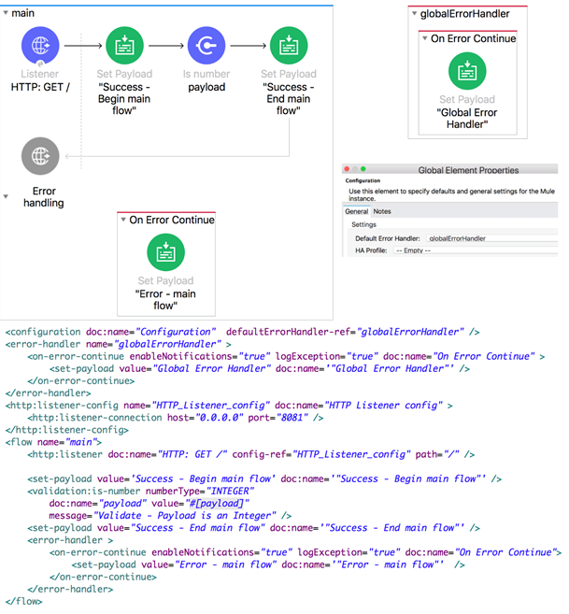](https://1.bp.blogspot.com/-pGSohypFxWg/XqWYUOmWlVI/AAAAAAAACBU/uTXQBJkPsNQwky_knk1kUYKx1-btRV7qgCLcBGAsYHQ/s1600/Error+Handler.png)

* Error - main flow
* Success - End main flow
* Validate - Payload is an Integer
* Global Error Handler

23. Refer to the exhibits. The main flow has an On Error Propagate scope. In the Configuration global element, default error handler is set to globalErrorHandler. A web client makes an HTTP GET request to the flow's HTTP Listener. The Is number validator then throws an error with message "Validate - Payload is an Integer".  What response message is returned to the web client?

[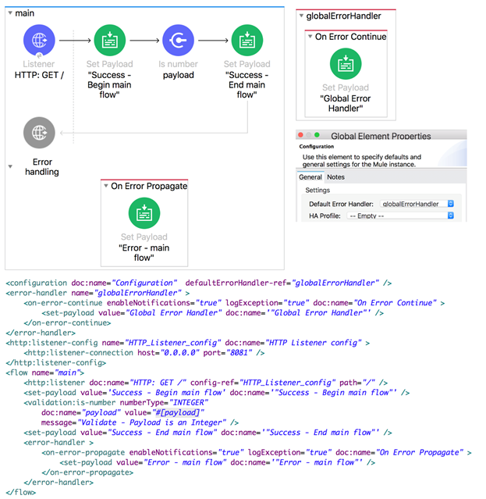](https://1.bp.blogspot.com/-nyR2W-oeonM/XqWZIfwEChI/AAAAAAAACBc/PRpn0rK6XGk2CKSaensVmGw6x9tTXs5GACLcBGAsYHQ/s1600/Error+Propagate.png)

* Error - main flow
* Success - End main flow
* Validate - Payload is an Integer
* Global Error Handler

24. Refer to the exhibits. The private flow has an On Error Propagate scope. In the Configuration global element, default error handler is set to globalErrorHandler. A web client makes an HTTP GET request to the flow's HTTP Listener. The Is number validator in the private flow then throws an error with message "Validate - Payload is an Integer". What response message is returned to the web client?

[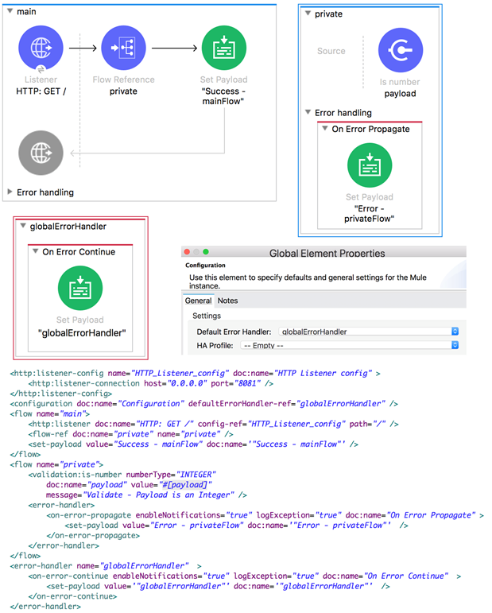](https://1.bp.blogspot.com/-HYwWQVLjb2I/XqWZzg7YsUI/AAAAAAAACB4/Oe7ux46rceo8PACMQ_719Sx6S7PWFrU8gCLcBGAsYHQ/s1600/Global+Error+Handler.png)

* globalErrorHandler
* Success - mainFlow
* Error - privateFlow
* Validate - Payload is a Number

25. Refer to the exhibits. The main flow has an On Error Continue scope and the private flow has an On Error Propagate scope. A web client makes an HTTP GET request to the HTTP Listener. The Is number validator in the private flow then throws an error with message "Validate - Payload is an Integer". What response message is returned to the web client?

[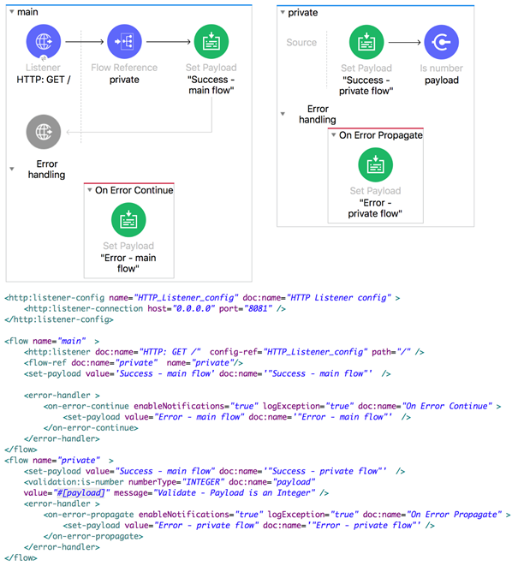](https://1.bp.blogspot.com/-z3vY97cyhW4/XqWbdxdKwmI/AAAAAAAACCY/o9Kg6j7IugAVrHzoZJunNd1qsyNrrHgzACEwYBhgL/s1600/Error+Continue.png)

* Error - main flow
* Error - private flow
* Success - private flow
* Validate - Payload is Integer

26. Refer to the exhibits. The main flow has an On Error Continue scope with type set to HTTP:NOT_FOUND. The Mule application configures globalErrorHandler as its default error handler. A web client posts a request to the HTTP Listener. The Transform Message component then throws a MULE:EXPRESSION error trying to convert the payload to application/xml. What response message is returned to the web client?

[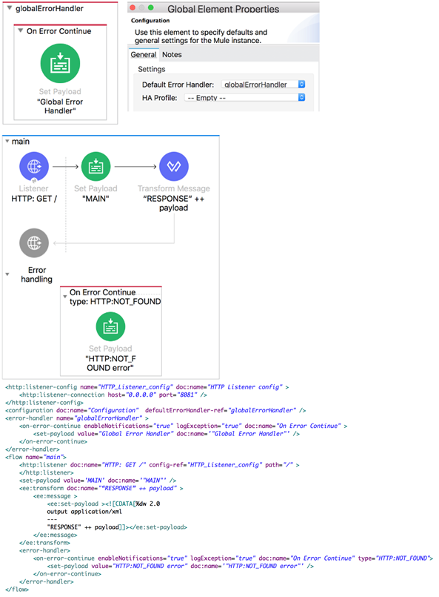](https://1.bp.blogspot.com/-Iv55rNPRFdc/XqWcPkfYbdI/AAAAAAAACC0/V8psITY3-5E0T4pUlKqdDJiKK_KrCCmdwCLcBGAsYHQ/s1600/Mule+Default.png)

* "HTTP:NOT_FOUND error"
* "MAIN"
* "Global Error Handler"
* The MULE:EXPRESSION error's message

27. Refer to the exhibit. An event payload contains an unordered array of flight objects, where every object has a price key and a toAirport key. What is valid DataWeave code to return flights with price under 500, grouped by toAirport in ascending order, with the lowest price first?

[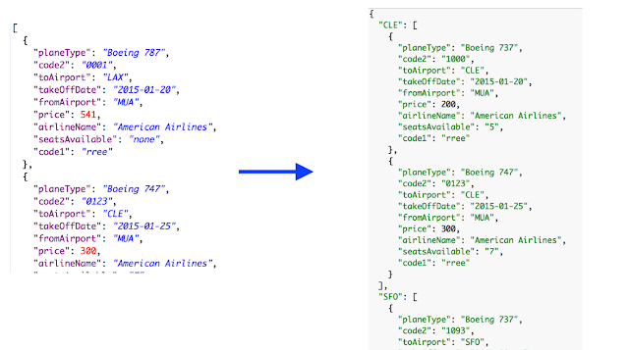](https://1.bp.blogspot.com/-2vLYnK8VZQI/XqWc1CeZs5I/AAAAAAAACDA/hiJbniGpjPAJ5mKm_L21Hb-ftGvvL6StACLcBGAsYHQ/s1600/Mule+Filter+Order+Group+By.png)

* payload groupBy $.toAirport filter $.price < 500 orderBy $.price
* payload groupBy $.toAirport filter $.price > 500 orderBy $.price
* payload filter $.price < 500 orderBy $.price groupBy $.toAirport
* payload filter $.price > 500 orderBy $.price groupBy $.toAirport

28. A Mule application has a main flow and a combineNames flow. In the main flow, a variable named fullName is set to the object {firstName: "Max", lastName: "Mule"}. What is valid DataWeave code to call the combineNames flow with the input object stored in the fullName variable?

* #[ dw::Flow::lookup( "combineNames", vars.fullName ) ]
* #[ lookup( "combineNames", vars.fullName ) ]
* #[ combineNames( vars.fullName ) ]
* #[ lookup( combineNames( vars.fullName ) ) ]

29. What is the correct way to format the decimal 20.3844 as a string to two decimal places?

* 20.3844 as String {format: ".0#"}
* 20.3844 as :string {format: ".0#"}
* 20.3844 as String as format: ".0#"
* 20.3844 as :string as format: ".0#"

30. Refer to the exhibit. What is the object type returned by the File List operation?

[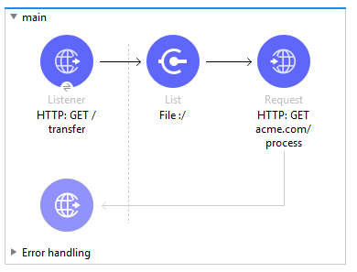](https://1.bp.blogspot.com/-Rdkqz3oLqWY/XqWlBTXuUrI/AAAAAAAACDs/3XcmeNb33QQpSmTbHmFlj1GaG2-2fT95ACLcBGAsYHQ/s1600/File+List+Operation.png)

* Array of Mule event objects
* Object of Mule event objects
* Array of String file names
* Object of String file names

31. Assume that a database table contains a recordID column that always increases as new records get added to the table. In a Mule application, what is the key process to enable manual watermarking for requests to a database using the Scheduler endpoint and the Database SELECT operation?

* Save the max recordID from the set of recordIDs in an ObjectStore and reference this recordID in subsequent database requests
* Enable automatic watermarking in the Database Select operation
* Set the Watermark column in the Scheduler endpoint to the recordID
* Save the max recordID from the set of recordIDs in a variable and reference this variable in subsequent database requests

32. A flow has a JMS Publish consume operation followed by a JMS Publish operation. Both of these operations have the default configurations. Which operation is asynchronous (does not wait for a response before continuing to the next event processor) and which operation is synchronous (blocks and waits for a response or timeout before continuing to the next event processor)?

* Publish consume: Asynchronous. Publish: Synchronous
* Publish consume: Asynchronous. Publish: Asynchronous
* Publish consume: Synchronous. Publish: Asynchronous
* Publish consume: Synchronous. Publish: Synchronous

33. Refer to the exhibits. The Set Payload component sets the payload to a Map object (not an Array). The File Write operation writes out files based on this Map object. How many files are written to the file system when the flow executes?

[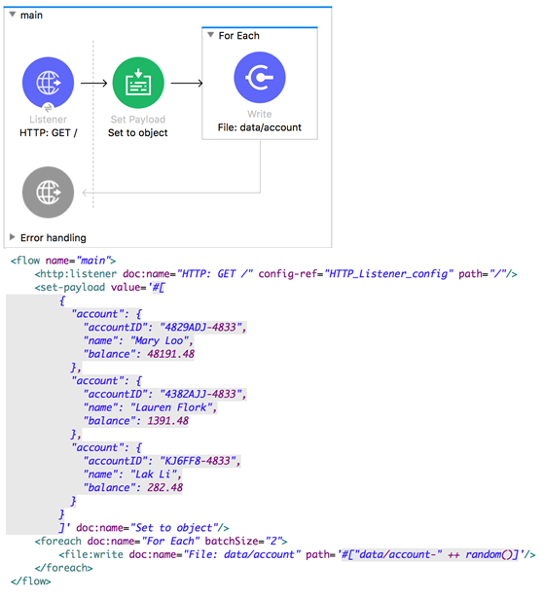](https://1.bp.blogspot.com/-2MFxKthDLMQ/XqWmIFxxDHI/AAAAAAAACD0/h8hB-whUyJQIvZGDBi5MgCWowZDiRX1dgCLcBGAsYHQ/s1600/File+System.png)

* 0
* 1
* 2
* 3

34. Refer to the exhibit. The payload [11,12,13] is passed to the Batch Job scope. In Batch_Step_1, a variable named batchStepPayload is set to the current payload. What is the value of the last log message after one batch job completes?

[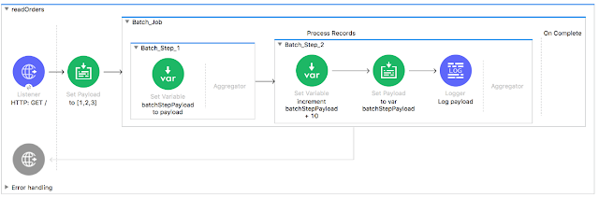](https://1.bp.blogspot.com/-z9Fkz8a9zzo/XqWmtUyDNgI/AAAAAAAACD8/1S7rjgWRQ8gDY5ikna9iKCRT9iGS7Q0yQCLcBGAsYHQ/s1600/Batch+Scope.png)

* 13
* [11,12,13]
* 12
* 11

35. Refer to the exhibits. What is the output of the Logger component in the Batch Job?

[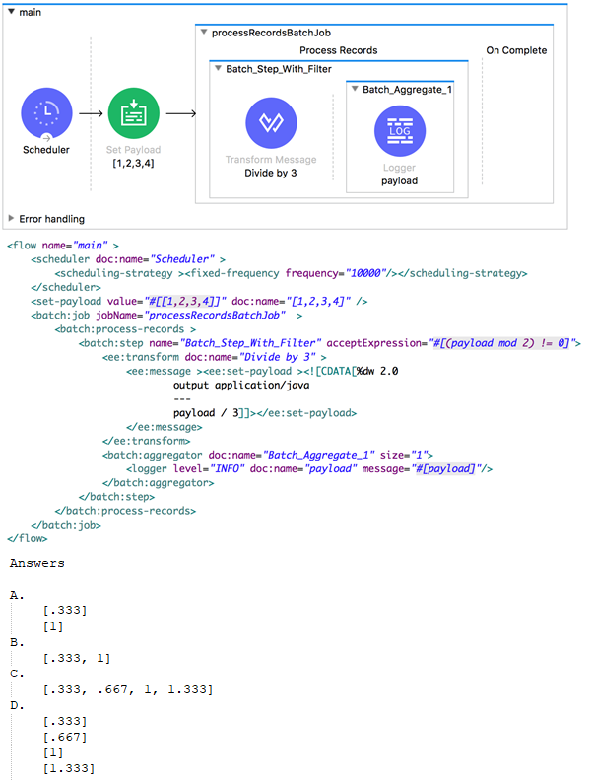](https://1.bp.blogspot.com/-IIXEfrfgHeA/XqWoBCTU2-I/AAAAAAAACEI/wJBTkfcWmnc9Iek3UqWNBMcBcSeX8kccQCLcBGAsYHQ/s1600/Batch+Job.png)

* A
* B
* C
* D

**1. How would you debug Mule applications?**

 Using breakpoints

 Checking RAML

 By Deploying apps on production

 Cannot do it

**2. What does to the attributes of a Mule event happen in a flow after an outbound HTTP Request is made?**

 Attributes do not change.

 Previous attributes are passed unchanged.

 Attributes are replaced with new attributes from the HTTP Request response.

 New attributes may be added from the HTTP response headers, but no headers are ever removed.

**3. The new RAML spec has been published to Anypoint Exchange with client credentials.  
  
What is the next step to gain access to the API?**

 Email the owners of the AP

 Create a new client application.

 No additional steps needed.

 Request access to the API in Anypoint Exchange.

**4. What is the difference between a subflow and a sync flow?**

 Sync flow has no error handling of its own and subflow does.

 Subflow has no error handling of its own and sync flow does.

 Subflow is synchronous and sync flow is asynchronous.

 No difference.

**5. What is not an asset?**

 Exchange

 Template

 Example

 Connector

**6. How to import Core (dw::Core) module into your DataWeave scripts?**

 import dw::core

 Not needed

 None of these

 import core

**7. What is the value of the stepVar variable after the processing of records in a Batch Job?**

 -1

 0

 Null

 Last value from flow

**8. What is the object type returned by the File List operation?**

 Object of String file names

 Array of String file names

 Object of Mule event objects

 Array of Mule event objects

**9. Where are values of query parameters stored in the Mule event by the HTTP Listener?**

 Payload

 Attributes

 Inbound Properties

 Variables

**10. How can you call a flow from Dataweave?**

 Not allowed

 Include function

 Look up function

 Tag function

**11. DataWeave is tightly integrated with ____________.**

 Mule runtime

 All APIs

 Flow Designer

 Exchange

**12. In the Database On Table Row operation, what does the Watermark column enable the On Table Row operation to do?**

 To save the most recent records retrieved from a database to enable database caching.

 To enable duplicate processing of records in a database.

 To avoid duplicate processing of records in a database.

 To delete the most recent records retrieved from a database to enable database caching.

**13. An API has been created in Design Center.  
  
What is the next step to make the API discoverable?**

 Deploy the API to a Maven repository.

 Publish the API from inside flow designer.

 Publish the API to Anypoint Exchange.

 Enable autodiscovery in API Manager.

**14. What is the correct way to format the decimal 200.1234 as a string to two decimal places?**

 200.1234 as string {format: ".0#"}

 200.1234 as string as format: ".0#"

 200.1234 as String {format: ".0#"}

 200.1234 as String as format: ".0#"

**15. How is policy defined in terms of classloader of an API?**

 Classloader isolation does not exist between the application, the runtime and connectors, and policies.

 Classloader isolation exists between the application, the runtime and connectors, and policies.

 None of these.

 Classloader isolation partially exists between the application, the runtime and connectors, and policies.

**16. According to Mulesoft, how are Modern APIs treated as?**

 products

 code

 soap services

 organizations

**17. According to Semantic Versioning, which version would you change for incompatible API changes?**

 MINOR

 PATCH

 MAJOR

 No change

**18. What is the use of DevKit in Mule 4?**

 Facilitates communication between third-party systems and Mule applications.

 No use.

 Offers connector end user support in a few aspects of Mule app design.

 Enables the development of Anypoint Connectors.

**19. A Scatter-Gather processes a number of separate HTTP requests. Each request returns a Mule event with a JSON payload.  
  
What is the final output of the Scatter-Gather?**

 An Object containing all Mule event Objects.

 An Array containing all Mule event Objects.

 None of these.

 The last Mule event object.

**20. What are the latest specification of RAML available?**

 0.8

 1

 2

 1.8

Answers:

1. How would you debug Mule applications?

* **Using breakpoints**
* Checking RAML
* By Deploying apps on production
* Cannot do it

2. What does to the attributes of a Mule event happen in a flow after an outbound HTTP Request is made?

* Attributes do not change.
* Previous attributes are passed unchanged.
* **Attributes are replaced with new attributes from the HTTP Request response.**
* New attributes may be added from the HTTP response headers, but no headers are ever removed.

3. The new RAML spec has been published to Anypoint Exchange with client credentials.  
What is the next step to gain access to the API?

* Email the owners of the AP
* Create a new client application.
* No additional steps needed.correct
* **Request access to the API in Anypoint Exchange.**

4. What is the difference between a subflow and a sync flow?

* Sync flow has no error handling of its own and subflow does.
* **Subflow has no error handling of its own and sync flow does.**
* Subflow is synchronous and sync flow is asynchronous.
* No difference.

5. What is not an asset?

* **Exchange**
* Template
* Example
* Connector

6. How to import Core (dw::Core) module into your DataWeave scripts?

* import dw::core
* **Not needed**
* None of these
* import core

7. What is the value of the stepVar variable after the processing of records in a Batch Job?

* -1
* 0
* **Null**
* Last value from flow

8. What is the object type returned by the File List operation?

* Object of String file names
* Array of String file names
* Object of Mule event objects
* **Array of Mule event objects**

9. Where are values of query parameters stored in the Mule event by the HTTP Listener?

* Payload
* **Attributes**
* Inbound Properties
* Variables

Explanation:  
  
In Mule4 – #[attributes.queryParams.{paramaterName}]

10. How can you call a flow from Dataweave?

* Not allowed
* Include function
* **Look up function**
* Tag function

11. DataWeave is tightly integrated with ____________.

* **Mule runtime**
* All APIs
* Flow Designer
* Exchange

12. In the Database On Table Row operation, what does the Watermark column enable the On Table Row operation to do?

* To save the most recent records retrieved from a database to enable database caching.
* To enable duplicate processing of records in a database.
* **To avoid duplicate processing of records in a database.**
* To delete the most recent records retrieved from a database to enable database caching.

13. An API has been created in Design Center.  
What is the next step to make the API discoverable?

* Deploy the API to a Maven repository.
* Publish the API from inside flow designer.
* **Publish the API to Anypoint Exchange.**
* Enable autodiscovery in API Manager.

Explanation:  
  
Anypoint Exchange enables publishing, sharing, and searching of APIs.

14. What is the correct way to format the decimal 200.1234 as a string to two decimal places?

* 200.1234 as string {format: ".0#"}
* 200.1234 as string as format: ".0#"
* **200.1234 as String {format: ".0#"}**
* 200.1234 as String as format: ".0#"

15. How is policy defined in terms of classloader of an API?

* Classloader isolation does not exist between the application, the runtime and connectors, and policies.
* **Classloader isolation exists between the application, the runtime and connectors, and policies.**
* None of these.
* Classloader isolation partially exists between the application, the runtime and connectors, and policies.

16. According to Mulesoft, how are Modern APIs treated as?

* **products**
* code
* soap services
* organizations

17. According to Semantic Versioning, which version would you change for incompatible API changes?

* MINOR
* PATCH
* **MAJOR**
* No change

18. What is the use of DevKit in Mule 4?

* Facilitates communication between third-party systems and Mule applications.
* **No use. correct**
* **Offers connector end user support in a few aspects of Mule app design.**
* Enables the development of Anypoint Connectors.

19. A Scatter-Gather processes a number of separate HTTP requests. Each request returns a Mule event with a JSON payload.  
What is the final output of the Scatter-Gather?

* **An Object containing all Mule event Objects**.
* An Array containing all Mule event Objects.
* None of these.
* The last Mule event object.

20. What are the latest specification of RAML available?

* 0.8
* **1**
* 2
* 1.8

**How would you debug Mule applications?**

* **Using breakpoints**correct
* Checking RAML
* By Deploying apps on production
* Cannot do it

**2. What does to the attributes of a Mule event happen in a flow after an outbound HTTP Request is made?**

* Attributes do not change.
* Previous attributes are passed unchanged.
* **Attributes are replaced with new attributes from the HTTP Request response.**correct
* New attributes may be added from the HTTP response headers, but no headers are ever removed.

**3. The new RAML spec has been published to Anypoint Exchange with client credentials.  
  
What is the next step to gain access to the API?**

* Email the owners of the AP
* Create a new client application.
* **No additional steps needed.**correct
* Request access to the API in Anypoint Exchange.

**4. What is the difference between a subflow and a sync flow?**

* Sync flow has no error handling of its own and subflow does.
* **Subflow has no error handling of its own and sync flow does.**correct
* Subflow is synchronous and sync flow is asynchronous.
* No difference.

**5. What is not an asset?**

* **Exchange**correct
* Template
* Example
* Connector

**6. How to import Core (dw::Core) module into your DataWeave scripts?**

* import dw::core
* **Not needed**correct
* None of these
* import core

**7. What is the value of the stepVar variable after the processing of records in a Batch Job?**

* -1
* 0
* **Null**correct
* Last value from flow

**8. What is the object type returned by the File List operation?**

* Object of String file names
* Array of String file names
* Object of Mule event objects
* **Array of Mule event objects**correct

**9. Where are values of query parameters stored in the Mule event by the HTTP Listener?**

* Payloadcorrect
* **Attributes**correct
* Inbound Properties
* Variables

Explanation:

In Mule4 - #[attributes.queryParams.{paramaterName}]

**10. How can you call a flow from Dataweave?**

* Not allowed
* Include function
* **Look up function**correct
* Tag function